15 docker commands

1. Docker pull

Eg: docker pull mongo

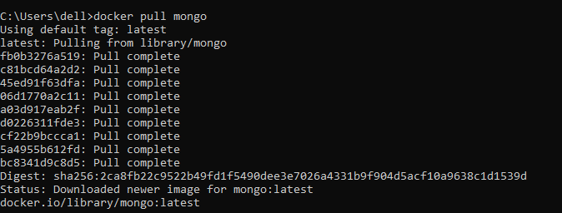

1. Docker run

docker run -it -d mongo



1. Docker ps

docker ps - This command is used to list the running containers



1. Docker ps -a

docker ps -a : used to list all containers



1. Docker exec

docker exec -it <container id> bash

This command is used to access the running container



1. Docker stop

docker stop < container id>

This command is used to stop a running container

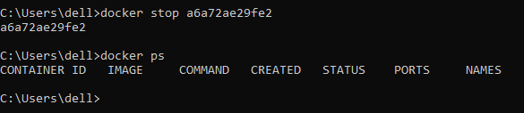

1. Docker kill

docker kill <container id>

This command stops the container immediately

Docker stop command gives the container time to shutdown gracefully.

But when it is taking too much time for getting the container to stop, we can opt to kill it.



1. docker commit

docker commit <conatainer id> <username/imagename>

This command creates a new image of an edited container on the local system



1. docker login

This command is used to login to the docker hub repository

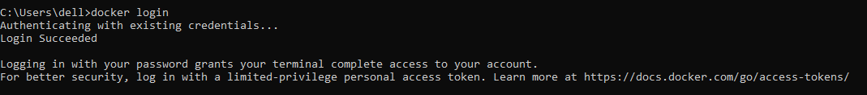

1. docker push

docker push <username/image name>

This command is used to push an image to the docker hub repository

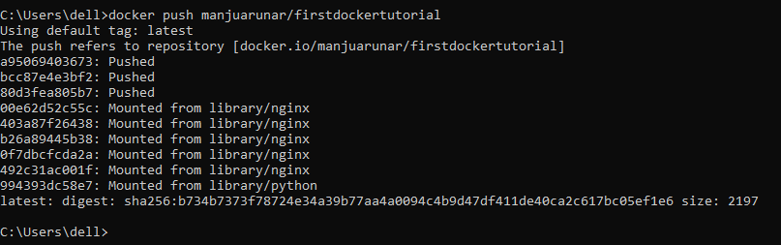

1. docker images

This command lists all the locally stored docker images.

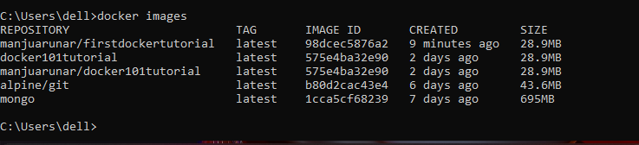

1. docker rm

docker rm <container id>

This command is used to delete a stopped container.



1. docker rmi

docker rmi <image-id>

This command is used to delete an image from local storage.

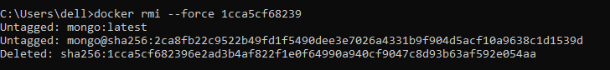

1. docker build

This command is used to build an image from a specified Dockerfile

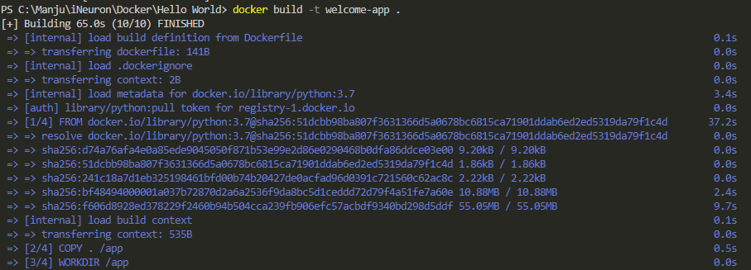

1. docker start

docker start <container id>

This command is used to start a stopped container

